Implementation Recommendations and Usage Boundaries for the Two-Dimensional Probability of Collision Calculation

AAS 19-632

Doyle T. Hall[1]

The two-dimensional (2D) probability of collision ($P_{c}$) estimation method relies on several assumptions that must be satisfied for accurate results. Monte Carlo analysis of ~44,000 conjunctions indicates that 2D- $P_{c}$ provides accurate estimates for most typical conjunctions, but occasionally underestimates $P_{c}$ significantly, indicating an assumption violation. A test to detect large-amplitude underestimation inaccuracies can be based on how much “offset-from-TCA” 2D- $P_{c}$ values vary during a well-defined time interval bracketing closest approach. The test successfully detects all large-amplitude 2D- $P_{c}$ underestimations found to date, but with a high false-alarm rate. The analysis also provides implementation recommendations and usage boundaries for the 2D- $P_{c}$ method.

Introduction

The two-dimensional probability of collision approximation, which first entered the literature in 19921 and is used by many conjunction assessment practitioners, relies on several assumptions that must be satisfied in order to produce accurate results.2,3 High-fidelity brute force Monte Carlo (BFMC) simulations, which do not invoke these assumptions, can be used to test the accuracy of the 2D- $P_{c}$ method.4 BFMC analysis of ~44,000 conjunctions indicates that the 2D- $P_{c}$ approximation provides sufficiently accurate estimates to enable effective collision risk assessment for the vast majority of events processed by NASA’s Conjunction Assessment Risk Analysis (CARA) team. This majority generally corresponds to high relative-velocity encounters between well-tracked objects. However, for about 0.05% of the analyzed conjunctions, 2D- $P_{c}$ underestimates the BFMC- $P_{c}$ value by a factor of 2.5 or more. In several cases, the 2D- $P_{c}$ method underestimates by a factor of 10 or more. This study focuses on developing a test to detect such large-amplitude 2D- $P_{c}$ underestimation inaccuracies.

the 2D- $P_{c}$ Collision Probability Estimation Method

In 1992, Foster and Estes1 originally developed the 2D- $P_{c}$ method to quantify collision risks posed to the International Space Station by other cataloged Earth-orbiting satellites. The method approximates *Pc* values semi-analytically using 2-dimensional (2D) numerical integration. In 2000, Akella and Alfriend2 reformulated the theory to show how a 2D- $P_{c}$ estimate can be equivalently expressed as a time integral spanning the entire duration of an on-orbit encounter.4 A conjunction’s 2D- $P_{c}$ estimate depends on the combined hard-body radii of the primary and secondary satellites involved in the encounter, as well as their mean orbital trajectories and associated position uncertainties.1-3,5 As discussed in detail by Chan3 and Coppola5, the 2D- method also relies on several assumptions that must be sufficiently satisfied in order to provide accurate $P_{c}$ estimates.

2D- $P_{c}$ Estimation Method Assumptions

Three important assumptions1-3,5 underlie the 2D- $P_{c}$ formulation:

1) At the conjunction’s nominal time of closest approach (TCA), the relative primary-to-secondary position uncertainty distribution can be approximated as a single Gaussian ⎯ i.e., a multivariate normal distribution calculated using a single 3×3 covariance matrix.

2) During the event, the relative satellite trajectories can be approximated as rectilinear.

3) During the event, the relative position covariance matrix can be approximated as unchanging, or constant in time.

If any of these three assumptions are violated, then 2D- $P_{c}$ estimates can be inaccurate. Assumption 1 relies on both objects having high quality, recent tracking data and orbital determination (OD) solutions6,7 for which the relative position covariance provides an accurate approximation of the actual uncertainty. The existence of a non-positive definite (NPD) state covariance matrix8 provides one example of a violation of assumption 1. The linear-encounter assumption 2 and constant-covariance assumption 3 both rely on the event being a “short-encounter” interaction5, which is naturally satisfied for high relative-velocity events, but not necessarily for slower interactions such as encounters between closely-spaced, nearly co-orbiting objects.

Short-Term Encounter Validity Interval

As mentioned previously, Akella and Alfriend2 show that a 2D- $P_{c}$ estimate can be expressed using a time integral, indicating that collision probability accumulates over a finite period of time during an encounter between two tracked objects ⎯ which can also be demonstrated using Monte Carlo methods.4 A conjunction’s effective duration can be considered to be the period in which $P_{c}$ increases from zero up to a final value to within some precision tolerance level (corresponding to ~10-16 for double-precision numerical processing).3,5 In addition, Chan’s analysis3 of 2D- validity requirements indicates that the linear-encounter assumption must be satisfied throughout an encounter region spanning 17 relative position uncertainty standard deviations (i.e., within ±8.5σ of the point of closest approach). Coppola’s analysis5 extends this concept even further, indicating that both the linear-encounter and constant-covariance assumptions must be satisfied throughout a well-defined time span, TCA ± Δ*t*, known as the *short-term encounter validity interval,* which has half width

$t=max⁡(\left|τ_{0}\right|,\left|τ_{1}\right|,τ_{1}-τ_{0})$ (1)

Here $τ_{0}$ and $τ_{1}$ denote the beginning and ending of the conjunction duration,5 measured relative to TCA, which depend on the precision tolerance (taken to be $γ={10}^{-16}$ for all analyses presented here), as well as the TCA primary-to-secondary relative position vector and associated covariance matrix. (Coppola5 provides detailed expressions for $τ_{0}$ and $τ_{1}$ that are not reproduced here.) Short-term encounter validity intervals vary from conjunction to conjunction, with high relative-velocity events having shorter $t$ values than slower interactions.

Offset-from-TCA 2D- $P_{c}$ Estimate Variations

Normally, 2D- $P_{c}$ estimates employ relative positions and covariances estimated precisely at a conjunction’s nominal TCA ⎯ the time when the distance between the best-estimate (mean) positions of the primary and secondary satellites is minimized. CARA generally calculates and employs such “at-TCA” 2D- $P_{c}$ estimates for initial conjunction risk assessments. However, 2D- $P_{c}$ estimates can also be calculated using states and covariances defined at times offset from TCA. If the offset time is sufficiently short (e.g., << $∆t$) , such “offset-from-TCA” 2D- $P_{c}$ estimates will not differ appreciably from the at-TCA estimate.3 In fact, for most events analyzed by CARA, the offset time can span the entire short-term encounter validity interval and still yield approximately the same 2D- $P_{c}$ value (as will be demonstrated later). Some conjunctions, however, show large offset-from-TCA 2D- $P_{c}$ variations over their short-term encounter validity intervals.

The CARA system receives data similar to that contained in a standard *conjunction data messag*e (CDM) for each processed conjunction.4,8 In addition to a conjunction’s nominal TCA, CDMs also contain data for both the primary and secondary satellites that can be converted into at-TCA inertial-frame cartesian orbital states and associated covariance matrices.8 Offset-from-TCA states and covariances can be estimated by propagating these at-TCA quantities both forward and backward in time over the short-term encounter validity interval, $-∆t≤t≤∆t$, where $t$ indicates the offset time measured relative to nominal TCA. This analysis employs Keplerian 2-body equations of motion and transition matrices for these state/covariance propagations, which approximate the effects of both curvilinear trajectories and temporally changing covariances. These 2-body propagations can be performed directly using a cartesian position/velocity orbital state representation9 or by converting to an equinoctial element state representation10,11 ⎯ two approaches found to produce equivalent results in this analysis. These propagated states and covariances can then be used to calculate offset-from-TCA 2D- $P_{c}$ estimates, denoted in this analysis as $P_{c}(t)$, with $P_{c,0}=P_{c}\left(0\right)$ representing the at-TCA 2D- $P_{c}$ estimate.

When calculating $P_{c}(t)$, care must be taken to estimate offset-from-TCA close approach distances, $r_{ca}(t)$, which can differ from the at-TCA value. Significant variations in $r_{ca}(t)$ can occur if the relative primary-to-secondary trajectory curves significantly during the $-∆t≤t≤∆t$ interval, potentially leading to large variations in $P_{c}(t)$, as discussed in detail by Chan3 (specifically, see Figure 3.3 in reference 3). This implies that large $P_{c}(t)$ variations can indicate that a conjunction potentially fails to satisfy the 2D- $P_{c}$ assumption of linear trajectories. Similarly, variations in $P_{c}(t)$ can also occur if the relative position covariance matrix changes significantly during $-∆t≤t≤∆t$. So large $P_{c}(t)$ variations can also indicate a failure to satisfy the 2D- $P_{c}$ assumption of constant covariance.

Figure 1 shows offset-from-TCA 2D- $P_{c}$ variations for two CARA conjunctions that have been analyzed in detail previously using BFMC simulations.4 The left plot shows the relatively small $P_{c}(t)$ variations calculated for a conjunction between NASA’s *Aqua* satellite and a debris object, for which the 2D- $P_{c}$ and BFMC- $P_{c}$ method estimates match one another to within Monte Carlo estimation uncertainty (i.e., $P_{c,0}$ ≈ BFMC- $P_{c}$ as shown in Figure 1 of Hall *et al.*4). This contrasts with the right plot, which shows the large-amplitude $P_{c}(t)$ variations calculated for a *Van Allen* satellite conjunction, for which $P_{c,0}$ underestimates BFMC- $P_{c}$ by a factor of about 300 (as shown in Figure 4 of Hall *et al.*4) Notably, all conjunctions found so far for which $P_{c,0}$ significantly underestimates BFMC- $P_{c}$ show such large-amplitude $P_{c}(t)$ variations, without exception. Conversely, most conjunctions for which $P_{c,0}$ accurately matches BFMC- $P_{c}$, show relatively small $P_{c}(t)$ variations. As explained in more detail later, this observation provides the basis for a diagnostic test to check for potential 2D- $P_{c}$ method inaccuracies.

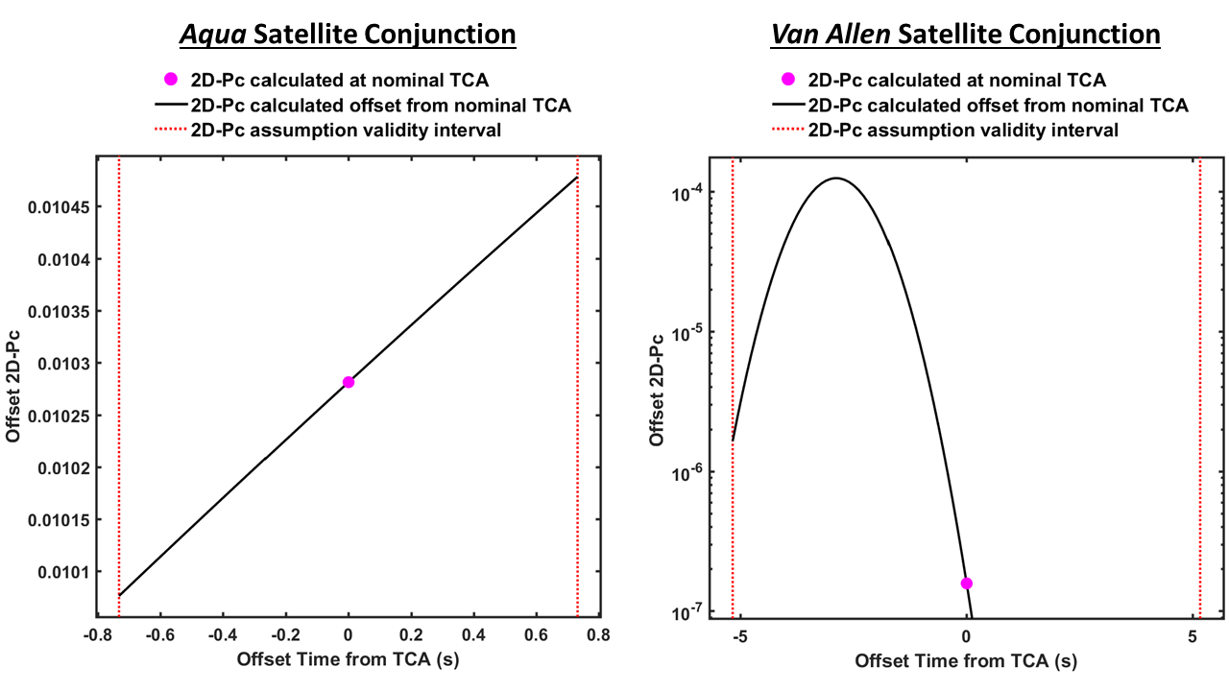

Figure 1. Offset-from-TCA 2D- $P_{c}$ estimates for an *Aqua* conjunction (left) for which the 2D- $P_{c}$ and BFMC- $P_{c}$ estimates agree, and a *Van Allen* conjunction for which 2D- $P_{c}$ significantly underestimates BFMC- $P_{c}$.

Comparisons of 2D- $P_{c}$ and BFMC- $P_{c}$ Estimates

Figure 2 shows a comparison of at-TCA 2D- $P_{c}$ estimates (horizontal axis) and BFMC- $P_{c}$ estimates (vertical axis) for a representative set of 43,595 conjunctions processed by CARA from 2017-05-01 to 2018-11-15. This set includes all events archived in CARA’s database over that period that have $P_{c,0}≥{10}^{-7}$ (the criterion corresponding to medium- and high-priority risk assessments performed within the CARA system), as well as a primary OD epoch age of ≤10 days and a secondary OD epoch age of ≤20 days. Conjunction short-term validity intervals vary significantly among these events, with a median $t$ of 1.2 s, and a 95% range of 0.17 s ≤ $t$ ≤ 9.8 s.

The BFMC- $P_{c}$ estimates and error bars plotted in Figure 2 employ the “BFMC from-TCA/CDM-mode” estimation methodology described in detail in Hall *et al*.4 (The vertical error bars represent 95% confidence BFMC-*Pc* uncertainty intervals.) Figure 2 indicates that major BFMC-*Pc* vs 2D- $P_{c}$ differences occur in both directions, BFMC-*Pc* << and BFMC-*Pc* >> , with the latter type causing more concern because, for these conjunctions, the 2D-*Pc* approximation significantly underestimates the actual conjunction risk indicated by the high-fidelity BFMC simulation, whereas the former represents an overly conservative collision risk estimation.

Large-Amplitude 2D- $P_{c}$ Underestimation Inaccuracies

This analysis focuses on designing a test to detect “large-amplitude 2D- $P_{c}$ underestimations” defined here as conjunctions with BFMC- $P_{c}$/ $P_{c,0}≥F_{b}$, where $F_{b}$ denotes the factor bounding what is considered a large-amplitude underestimation. The colored diamonds in Figure 2 indicate the existence of 22 large-amplitude 2D- $P_{c}$ underestimations for $F_{b}=2.5$; these all appear well above the diagonal line in the plot. The black cross (**+**) symbols in Figure 2 show the much larger number of remaining conjunctions, plotted with error bars corresponding to 95% confidence Monte Carlo uncertainty intervals.4 The black symbols also indicate the existence of several large-amplitude 2D- $P_{c}$ overestimations, which appear well below the diagonal line (note: several of these had zero collisions registered in the BFMC simulations, and are represented in Figure 2 using downward pointing triangles with a single-sided error bar).

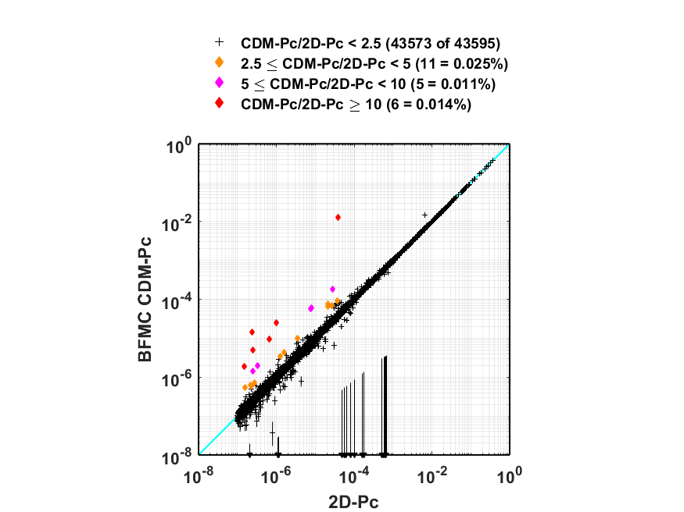

Figure 2. A comparison of 2D- $P_{c}$ and BFMC- $P_{c}$ estimates for 43,595 CARA conjunctions. Colored diamonds show large-amplitude 2D- $P_{c}$ method underestimation inaccuracies.

The comparison shown in Figure 2 confirms that the 2D- $P_{c}$ approximation produces sufficiently accurate estimates to enable effective risk assessments for the majority of CARA conjunctions.4 Among this representative set of ~44,000 conjunctions, only 22 events suffer from 2D- $P_{c}$ underestimations by a factor of $F_{b}=2.5$ or more; 11 of these represent underestimations for $F_{b}=5$, and 6 for $F_{b}=10$. Assuming that the data set analyzed here is representative of future conjunctions, these small fractions can be interpreted as probabilities that such 2D- $P_{c}$ underestimations will occur in the future, equaling ~5×10-4, ~2.5×10-4, and ~1.4×10-4, respectively, for the *Fb* values given above. Notably, these probabilities exceed (but are roughly comparable to) the “red” collision probability of 10-4 that the CARA team employs for high-priority risk assessments, which can ultimately lead to satellite operators planning and executing maneuvers to mitigate collision risk. This probability comparison emphasizes the need for a procedure to detect and mitigate 2D- $P_{c}$ underestimation inaccuracies.

Measuring Offset-from-TCA 2D- $P_{c}$ Variations

As discussed previously, large variations in offset-from-TCA 2D- $P_{c}$ estimates can indicate that a conjunction potentially fails to satisfy the 2D- $P_{c}$ assumptions of linear motion and/or constant relative position covariance. Measuring the amplitude of such $P_{c}(t)$ variations forms the basis of the 2D- $P_{c}$ method diagnostic test and usage boundaries presented in this analysis. One measure of the amplitude of $P_{c}(t)$ variations can be defined as

$V'=\log_{10}\left[{P_{c}^{min}}/{P_{c}^{max}}\right]$ (2)

where

$P_{c}^{min}=\min_{|t|≤∆t }\left[P_{c}(t)\right] and P_{c}^{max}=\max_{|t|≤∆t }\left[P_{c}(t)\right]$ (3)

denote the extrema over the short-term encounter validity interval, $-∆t≤t≤∆t$. These extrema can be determined numerically (e.g., using a bisection search optimization method12). Analysis indicates that the metric $V'$ can be used as an indicator of overall 2D- $P_{c}$ method inaccuracies, including both underestimations and overestimations. A slightly different variation metric, however, has been found to perform somewhat better as a diagnostic indicator of potential 2D- $P_{c}$ underestimations alone, in that it produces fewer false alarms

$V=\log_{10}\left[{P_{c}^{min}}/{P_{c}^{mid}}\right]$ (4)

where

$P_{c}^{mid}={({P_{c,0}+P}_{c}^{min})}/2$ (5)

denotes the midpoint between the at-TCA and minimum offset-from-TCA 2D- $P_{c}$ values. For reference, the *Aqua* satellite conjunction with the small $P_{c}(t)$ variations shown on the left panel of Figure 1 has $V=$ 0.013 measured over an interval with half-width $∆t$ = 0.7 s, whereas the *Van Allen* event shown on the right panel has a much larger variation of $V=$ 3.2 over $∆t$ = 5 s.

Notably, calculating $V$ requires numerically finding the minima and maxima of $P_{c}(t)$ over the validity interval $-∆t≤t≤∆t$, which entails many 2D- $P_{c}$ method computations. This increased computational load can be reduced by using a software implementation of the 2D- $P_{c}$ method optimized for computation speed.

Including the Effects of Non-Positive Definite Covariances

The metric $V$ can be modified to additionally include the effects of inaccuracies introduced by NPD state covariance matrices. As discussed previously, NPD covariances indicate a potential violation of the first of the three 2D- $P_{c}$ method assumptions. NPD covariances also represent physically implausible uncertainty distributions, and can potentially prevent $P_{c}$ estimation.8 For instance, the 2D- $P_{c}$ method employs a marginalized 2×2 covariance matrix indicating the combined relative position uncertainty projected onto the conjunction plane1-3,5, and cannot provide a physically-plausible estimate if this 2×2 matrix is NPD.8 Fortunately, this occurs with a near-zero frequency for CARA conjunctions (e.g., in about 1 out of 800,000 events8). No at-TCA 2×2 marginalized covariances were found to be NPD among the ~44,000 conjunctions analyzed here.

This analysis seeks to identify differences between the 2D- $P_{c}$ method and BFMC simulations. BFMC’s CDM-mode samples at-TCA equinoctial element state distributions for the primary and secondary satellites, and propagates the sampled states to determine how frequently collisions occur.4 Unfortunately, this Monte Carlo sampling process cannot employ NPD equinoctial state 6x6 covariances, which occur with non-zero frequency in CARA processing.8 During BFMC CDM-mode processing, if one or both of the at-TCA primary or secondary equinoctial state covariances is found to be NPD, they are remediated using an eigenvalue clipping method.4,8 To check if this affects the 2D- $P_{c}$ vs BFMC- $P_{c}$ comparison, these remediated equinoctial state covariances can be converted to cartesian state covariances, and then used as an alternate inputs for the 2D- $P_{c}$ method. Specifically, in such cases, this analysis generates two $P_{c}(t)$ curves for the unremediated and remediated covariances, and modifies the extrema from eq. (3) to include variations from both as follows

$P_{c}^{min}=min⁡\{\min_{|t|≤∆t }{{[P}_{c}^{u}\left(t\right)],\min_{|t|≤∆t }{{[P}_{c}^{r}\left(t\right)]\}}} and P_{c}^{max}=max⁡\{\max_{|t|≤∆t }{{[P}_{c}^{u}\left(t\right)],\max_{|t|≤∆t }{{[P}_{c}^{r}\left(t\right)]\}}}$ (6)

where $P_{c}^{u}\left(t\right)$ represents offset-from-TCA 2D- $P_{c}$ estimates for the unremediated covariances, and $P_{c}^{r}\left(t\right)$ for the remediated covariances. With these modifications, a variation metric $V$ that includes NPD effects can be calculated using eqs. (4) and (5). The $P_{c,0}$ value used in eq. (5) for this analysis, however, still represents the at-TCA 2D- $P_{c}$ estimated with the raw, unremediated conjunction covariance matrices.

Using Offset-from-TCA 2D- $P_{c}$ Variations as an Indicator of Underestimation Inaccuracies

Figure 3 shows the distribution of BFMC- $P_{c}$/2D- $P_{c}$ ratios as a function of the offset-from-TCA variation metric calculated as described above for the representative set of conjunctions analyzed here. Specifically, the top panel shows how BFMC- $P_{c}$/ $P_{c,0}$ ratios (vertical axis) vary with $V$ (horizontal axis). Again, the 22 colored diamonds show 2D- $P_{c}$ underestimations exceeding a factor of $F_{b}=2.5$ (with the same color coding used in Figure 2), and the black cross (**+**) symbols show the remaining events (plotted with no error bars here for clarity). The bottom panel of Figure 3 shows cumulative distribution functions (CDFs) for these sets (also using the same color coding).

The CDF curve plotted in black in Figure 3 indicates that most of the analyzed conjunctions have relatively small variation metrics: about half (53.5%) have $V≤0.1$ and two thirds (66.3%) have $V≤0.2$. However, all 22 conjunctions with 2D- $P_{c}$ underestimation factors exceeding $F_{b}=2.5$ show variation metrics with $V>0.8$. Notably, about 9% (or ~3,900) of the remaining events also have variation metrics above this boundary value of $V_{b}=0.8$. This means that the variation metric $V$ does not provide a perfect means of predicting such large-amplitude 2D- $P_{c}$ underestimations, but can be used as an indicator of potential underestimations. Assuming that the analyzed conjunction data set is representative of future events, this study indicates that if a future conjunction is found to have a variation metric exceeding a boundary value of $V_{b}=0.8$, then the 2D- $P_{c}$ method could potentially underestimate the actual $P_{c}$ by a factor of $F_{b}=2.5$ or more. To know definitively, a BFMC-fidelity method can then be used to estimate the actual $P_{c}$, which usually comes at the cost of considerably increased computation.

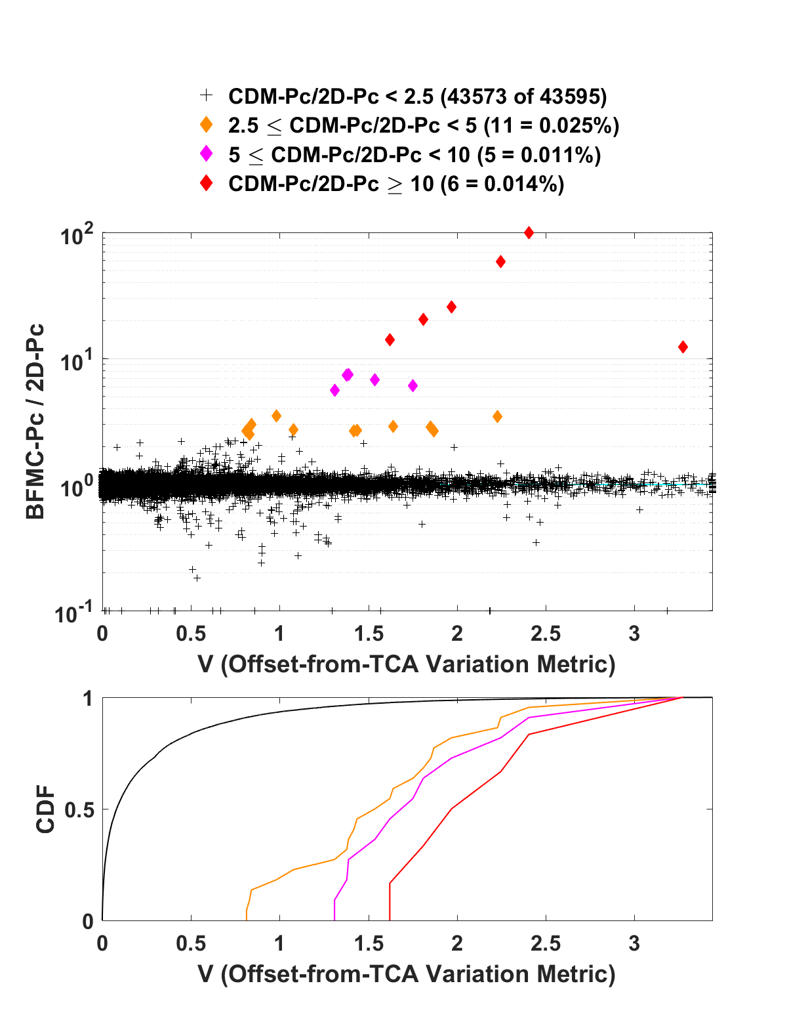

Figure 3. The distribution of BFMC- $P_{c}$/2D- $P_{c}$ ratios plotted as a function of the variation metric $V$ (top panel) with corresponding CDFs (bottom panel). Colored diamonds show 2D- $P_{c}$ method underestimations that exceed a factor of 2.5, which occur only for $V>0.8$.

A Diagnostic Test to Detect Potential 2D- $P_{c}$ Underestimation Inaccuracies

The test procedure developed in this study to diagnose potential 2D- $P_{c}$ method underestimations and mitigate associated risks can be summarized as follows: if the variation metric for an individual conjunction exceeds a boundary value (i.e., $V>V_{b}$), then the 2D- $P_{c}$ method might underestimate the actual collision probability by a factor of $F_{b}$ or more, and a high-fidelity $P_{c}$ estimate should be computed. The effectiveness of this diagnostic test can be characterized by how frequently it produces false alarms and missed detections. False alarms occur for conjunctions with $V>V_{b}$ for which the 2D- $P_{c}$ method does not underestimate the actual collision probability by a factor of $F_{b}$ or more. Missed detections occur for conjunctions with $V≤V_{b}$ for which 2D- $P_{c}$ does underestimate the actual probability by a factor of $F_{b}$ or more. Missed detections represent the more serious type of diagnostic error, because they can lead to a failure to detect and mitigate actual collision risks. False alarms, on the other hand, only prompt high-fidelity $P_{c}$ computations, which may require extra time and effort to complete, but ultimately yield higher quality risk assessments.

Based on the previous discussion of Figure 3, this diagnostic test should be expected to have a high false alarm frequency, because it most often will not reveal large-amplitude 2D- $P_{c}$ underestimations. Assuming that the analyzed data set is representative of future conjunctions, applying the test using a boundary metric of $V_{b}=0.8$ will prompt high-fidelity $P_{c}$ computations for ~9% of future events (the fraction with $V>V_{b}$) in order to find the ~0.05% of future events that suffer from actual 2D- $P_{c}$ underestimations with amplitude $F_{b}=2.5$ or greater.

The test’s frequency of missed detections can be reduced by adjusting the boundary value $V_{b}$. Again, assuming that the data set analyzed here is perfectly representative (or nearly representative) of future conjunctions, then the choice of $V_{b}=0.8$ by design will reveal all (or most) 2D- $P_{c}$ underestimations with amplitude $F_{b}=2.5$ or greater, corresponding to a zero (or small) frequency of missed detections.

Estimated Usage Boundaries for the 2D- $P_{c}$ Estimation Method

Table 1 reports the number of missed detections in the analyzed data set as a function of $V_{b}$ and $F_{b}$, formatted to ease estimating usage boundaries for the 2D- $P_{c}$ method and diagnostic test. Specifically, the first column of Table 1 lists the fraction of events with $V>V_{b}$, and the second column lists the corresponding $V_{b}$ value. The remaining columns tabulate the number of events for which 2D- $P_{c}$ underestimates BFMC- $P_{c}$ by a factor of $F_{b}$ or more, for $F_{b}$ values of {2.0, 2.5, 3.0, 5.0, 10.0}. The green/yellow/red color shading indicates the frequency of missed detections. Specifically, green indicates no missed detections, yellow a missed detection frequency of ≤10-4, and red a missed detection frequency >10-4. Table 1 can be used to estimate diagnostic test usage boundaries given a desired bounding underestimation factor $F_{b}$. For instance, eliminating all missed detections for a 2D- $P_{c}$ underestimation factor of $F_{b}=10$, requires a boundary of $V_{b}≈1.49$, prompting high-fidelity $P_{c}$ computations for about 3% of all events. Similarly, eliminating all missed detections at a level of $F_{b}=2$, requires $V_{b}≈0.14$ and high-fidelity computations for about 40% of all events.

Table 1. Missed detections as a function of $V_{b}$ and $F_{b}.$ Green shading indicates no missed detections, yellow a missed-detection frequency of ≤10-4 and red a frequency of >10-4.

|  |  |  |  |  |  |  |
| --- | --- | --- | --- | --- | --- | --- |
| Fraction with $V≥V_{b}$ (%) | Variation Metric Boundary, $V_{b}$ | 2D- $P_{c}$ Underestimation Boundary Factor, $F_{b}$ | | | | |
| 2.0 | 2.5 | 3.0 | 5.0 | 10.0 |
| 0.0 | ∞ | 34 | 22 | 14 | 11 | 6 |
| 1.0 | 2.19 | 30 | 18 | 10 | 8 | 3 |
| 2.0 | 1.75 | 26 | 14 | 8 | 6 | 1 |
| 3.0 | 1.49 | 22 | 10 | 5 | 3 | 0 |
| 5.0 | 1.18 | 16 | 5 | 2 | 0 | 0 |
| 7.5 | 0.93 | 13 | 3 | 1 | 0 | 0 |
| 10.0 | 0.76 | 7 | 0 | 0 | 0 | 0 |
| 12.5 | 0.64 | 2 | 0 | 0 | 0 | 0 |
| 15.0 | 0.54 | 2 | 0 | 0 | 0 | 0 |
| 20.0 | 0.41 | 1 | 0 | 0 | 0 | 0 |
| 30.0 | 0.25 | 1 | 0 | 0 | 0 | 0 |
| 40.0 | 0.14 | 0 | 0 | 0 | 0 | 0 |

Discussion

This analysis demonstrates that the 2D- $P_{c}$ method occasionally underestimates actual conjunction collision probabilities, and that offset-from-TCA variations can be used as a diagnostic indicator of such inaccuracies. During the research and development of the specific test presented here, the CARA analysis team investigated several other candidate diagnostic indicators, with varying degrees of success. These include indicators based on a conjunction’s short-term encounter validity interval itself, $∆t$, as well as its ratio to the minimum primary/secondary orbital period. Another set of candidates measured Mahalanobis distance variations caused by including or excluding various effects to test a conjunction’s adherence to the 2D- $P_{c}$ assumptions, such as linear vs curved trajectories, zero vs non-zero velocity uncertainties, and remediated vs unremediated NPD covariances. Finally, another candidate indicator measured $P_{c}$ differences between the 2D- $P_{c}$ method and a different semi-analytical $P_{c}$ estimation method.13 None of these candidate indicators were found to work as well as the one presented here, based on their observed frequencies of raising false alarms and, more importantly, of failing to detect large-amplitude 2D- $P_{c}$ underestimations.

Conclusions

The analysis yields the following conclusions:

1. The 2D-*Pc* method underestimates high-fidelity BFMC CDM-mode *Pc* values by a factor of 2.5 or more for a small fraction (~0.05%) of the 43,595 representative CARA conjunctions analyzed in this study.
2. In order to provide an accurate estimate for a conjunction, the 2D-*Pc* method depends on three assumptions being satisfied: 1) the relative primary-to-secondary position uncertainty distribution can be approximated using a single 3×3 covariance matrix; 2) the relative satellite trajectories can be approximated as rectilinear; and 3) the relative position covariance matrix can be approximated as constant. Ideally, these 2D-*Pc* assumptions should be satisfied during a conjunction-specific time period known as the *short-term encounter validity interval*, TCA ± Δ*t*.5
3. Offset-from-TCA 2D-*Pc* estimates, $P_{c}(t)$, can be approximated throughout a conjunction’s short-term encounter validity interval by using 2-body state/covariance propagation, initiated with at-TCA states and covariances (such as those contained in a CDM).
4. Large-amplitude $P_{c}(t)$ variations indicate potential violations of the 2D-*Pc* assumptions, and can be quantified using the offset-from-TCA variation metric, $V$.
5. All conjunctions found to date for which 2D-*Pc* significantly underestimates BFMC- $P_{c}$ have relatively large $V$ metrics. Most conjunctions for which 2D-*Pc* accurately matches BFMC- $P_{c}$, have relatively small $V$ metrics.
6. The 2D-*Pc* underestimation diagnostic test procedure can be summarized as follows: if the variation metric for a conjunction exceeds a specified boundary value (i.e., $V>V_{b}$), then the 2D- $P_{c}$ method might underestimate the actual collision probability by a corresponding factor of $F_{b}$ or more, and a high-fidelity $P_{c}$ estimate should be computed.
7. The diagnostic test has a high false alarm rate because it prompts a relatively large number of high-fidelity $P_{c}$ computations, in order to find a much smaller number of actual large-amplitude 2D-*Pc* method underestimations.
8. The missed detection rate for the diagnostic test can be reduced by adjusting the boundary metric value, $V_{b}$. Among the data analyzed in this study, a value of $V_{b}=0.8$ eliminates all missed detections when testing for 2D- $P_{c}$ underestimations of amplitude $F_{b}=2.5$ or greater. Table 1 reports the frequency of missed detections for other boundary values of $V_{b}$ and $F_{b}$.

Symbols and acronyms

$F_{b}$ = the factor bounding what is considered a large-amplitude 2D- $P_{c}$ underestimation

$P_{c}$ = probability of collision for a conjunction between a primary and secondary satellite

$P_{c}(t)$ = a 2D- $P_{c}$ value estimated using states and covariances for an offset-from-TCA time $t$

$P_{c}^{r}(t)$ = a $P_{c}(t)$ curve calculated using remediated at-TCA postion+velocity covariances

$P_{c}^{u}(t)$ = a $P_{c}(t)$ curve calculated using unremediated at-TCA postion+velocity covariances

$P_{c,0}$ = $P_{c}(0)$ = the at-TCA 2D- $P_{c}$ estimate (i.e., estimated at a zero offset-from-TCA time)

$P_{c}^{min}$ = the minimum $P_{c}(t)$ over the short-term encounter validity interval $-∆t≤t≤∆t$

$P_{c}^{mid}$ = the mid-point value between $P_{c,0}$ and $P_{c}^{min}$

$P_{c}^{max}$ = the maximum $P_{c}(t)$ over the short-term encounter validity interval $-∆t≤t≤∆t$

$r_{ca}(t)$ = the close-approach distance estimated for an offset-from-TCA time $t$

$t$ = an offset time measured relative to a conjunction’s nominal TCA

$V$ = the offset-from-TCA 2D- $P_{c}$ variation metric, measuring the amplitude of $P_{c}(t)$ variations

$V_{b}$ = a boundary $V$ value; $V≥V_{b}$ indicates potential large-amplitude 2D- $P_{c}$ underestimations

$V'$ = an alternate metric measuring the amplitude of $P_{c}(t)$ variations

$∆t$ = the half-width of a conjunction’s short-term encounter validity interval

$γ$ = the precision tolerance used to define a conjunction’s duration, taken to be 10-16 here

$τ_{0}$ = the begin-time of a conjunction’s encounter duration measured relative to TCA

$τ_{1}$ = the end-time of a conjunction’s encounter duration measured relative to TCA

2D = two-dimensional

2D- $P_{c}$ = a collision probability estimated using the 2D collision probability method

BFMC = brute force Monte Carlo

BFMC- $P_{c}$ = a collision probability estimated using a BFMC simulation

CARA = Conjunction Assessment Risk Analysis

CDM = conjunction data message

NPD = non-positive definite

OD = orbit determination

NASA = National Aeronautics and Space Administration

TCA = time of closest approach

Acknowledgments

The author would like to thank Luis Baars, Steve Casali, Joseph Frisbee, Matthew Hejduk, Travis Lechtenberg, and Daniel Snow for several helpful discussions and analyses. The CARA analysis team would like to thank Salvatore Alfano for suggesting the amplitude of offset-from-TCA $P_{c}$ variations as an indicator of potential 2D- $P_{c}$ method inaccuracies.

References

1. J.L. Foster and H.S. Estes, “A Parametric Analysis of Orbital Debris Collision Probability and Maneuver Rate for Space Vehicles,” NASA/JSC-25898, Aug. 1992.
2. M.R. Akella and K.T. Alfriend, “The Probability of Collision Between Space Objects,” *Journal of Guidance, Control, and Dynamics*, Vol. 23, No. 5, pp. 769-772, 2000.
3. K. Chan, *Spacecraft Collision Probability*, El Segundo, CA, The AeroSpace Corporation, 2008.
4. D. Hall, S.J. Casali, L.C. Johnson, B.B. Skrehart, and L.G. Baars, “High-fidelity Collision Probabilities Estimated Using Brute Force Monte Carlo Simulations,” *AAS Astrodynamics Specialist Conference*, Snowbird, UT, Paper 18-244, Aug. 2018.
5. V.T. Coppola, “Evaluating the Short Encounter Assumption of the Probability of Collision Formula,” *AAS/AIAA Spaceflight Mechanics Meeting*, Charleston SC, Paper 12-248, Feb. 2012.
6. B.D. Tapley, B.E. Schutz, and G.H. Born, *Statistical Orbit Determination*, Elsevier Academic Press, Burlington, MA, 2004.
7. D.A. Vallado, *Fundamentals of Astrodynamics and Applications*, 2rd ed., Microcosm Press, El Segundo CA, 2001.
8. D.T. Hall, M.D. Hejduk, and L.C. Johnson, “Remediating Non-Positive Definite State Covariances for Collision Probability Estimation,” *AAS Astrodynamics Specialist Conference*, Columbia Valley, WA, Paper 17-567, 2017.
9. S.W. Shepperd, “Universal Keplerian State Transition Matrix,” *Celestial Mechanics*, Vol. 35, pp. 129-144, 1985.
10. D. Vallado, “Covariance Transformation for Satellite Flight Dynamics Operations,” *AAS/AIAA Astrodynamics Specialist Conference*, Big Sky, MT, Paper 03-526, 2003.
11. D. Vallado and S. Alfano, “Updated Analytical Partials for Covariance Transformations and Optimization,” *AAS/AIAA Space Flight Mechanics Meeting*, Williamsburg, VA, Paper 15-537, 2015.
12. W.H. Press *et al*, *Numerical Recipes in FORTRAN: The Art of Scientific Computing*, 2nd edition, Cambridge University Press, New York, NY, 1992.
13. V.T. Coppola, “Including Velocity Uncertainty in the Probability of Collision between Space Objects,” *AAS/AIAA Spaceflight Mechanics Meeting*, Charleston SC, Paper 12-247, Feb. 2012.

1. Senior Conjunction Assessment Research Scientist, Omitron Inc., 555 E. Pikes Peak Ave, #205, Colorado Springs, CO  80903.